**Azure Synapse Analytics vs Azure Data Factory vs Azure Databricks**

**1. Introduction**

Azure offers multiple services to build modern data platforms. Each tool overlaps in ingestion, transformation, orchestration, and analytics, yet they shine in different scenarios. As a data engineer, choosing the right service affects development velocity, operational complexity, cost, and scalability.

This guide will help you:

* Understand core capabilities of each service.
* Compare feature sets and pricing models.
* See real-world data engineering use cases.
* Decide which service (or combination) fits specific pipeline requirements.

**2. Service Overviews**

2.1 Azure Synapse Analytics

Azure Synapse Analytics is an integrated analytics suite that brings together enterprise data warehousing, big data analytics, and data integration pipelines under a single workspace.

* SQL-based analytics with dedicated and serverless pools
* Spark-powered analytics with managed Spark pools
* Built-in Data Factory capabilities for ETL/ELT
* Synapse Studio unified development environment

2.2 Azure Data Factory (ADF)

Azure Data Factory is a serverless data integration service focused on building, scheduling, and orchestrating ETL/ELT pipelines across on-premises and cloud sources.

* Visual pipeline authoring and mapping data flows
* Over 200 built-in connectors (SQL, NoSQL, SaaS, file stores)
* Trigger types: scheduled, tumbling window, event-based
* Git integration for CI/CD and collaboration

2.3 Azure Databricks

Azure Databricks is an Apache Spark-based analytics platform optimized for Azure, combining notebooks, jobs, and interactive clusters.

* Managed Spark environment with autoscaling
* Native support for Python, Scala, SQL, R
* Delta Lake for ACID transactions and schema enforcement
* Collaborative notebooks and MLflow integration

**3. Feature Comparison**

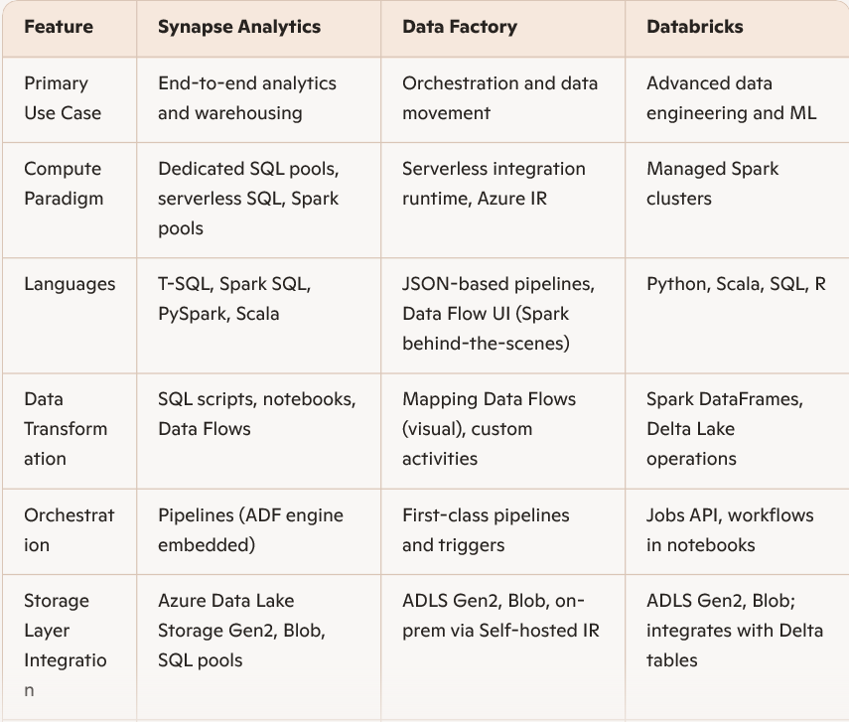

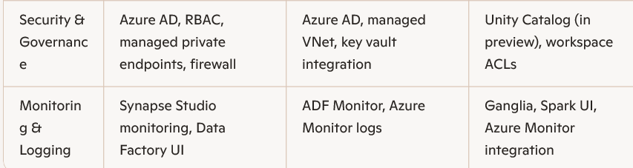

**4. Data Engineering Perspectives**

4.1 Ingestion & Orchestration

* Use Data Factory when your primary goal is **connecting diverse sources**, scheduling complex workflows, and handling control-flow logic (if/else, loops).
* Use Synapse Pipelines when you want **tighter integration** between ETL and analytics in the same workspace.
* Trigger Databricks jobs from ADF or Synapse when you need **distributed Spark compute** for heavy transformations.

4.2 Transformations & Analytics

* For SQL-centric data warehouses, Synapse’s dedicated SQL pools deliver massive parallel processing for star-schema models.
* When Spark is your engine of choice—especially for streaming or machine learning—Databricks offers the richest developer experience and Delta Lake reliability.
* Synapse Spark pools are a lighter-weight Spark option without the collaborative features of Databricks notebooks.

4.3 Development Workflow

* Data Factory pipelines are defined in JSON or via drag-and-drop UI. Good for data engineers who prefer declarative pipelines.
* Databricks notebooks support exploratory data analysis, real-time collaboration, and version control with Git integration.
* • Synapse Studio centralizes SQL scripts, Spark notebooks, and pipelines—ideal if you want one IDE for everything.

**5. Architecture Patterns & Use Cases**

5.1 Enterprise Data Warehouse

1. Ingest raw data from on-prem SQL using ADF
2. Land in ADLS Gen2 as Parquet
3. Use Synapse Dedicated SQL pool for modeling
4. Serve BI dashboards via Power BI direct query to Synapse

5.2 Big Data ETL & ML Pipelines

1. Stream IoT data into Event Hubs
2. Process with Databricks Structured Streaming and Delta Lake
3. Orchestrate notebook jobs via ADF
4. Register models in MLflow and deploy endpoints

5.3 Hybrid Orchestration

* ADF for control-flow across Azure, AWS, on-prem
* Trigger Databricks for Spark-heavy workloads
* Load curated tables into Synapse SQL pools for reporting

6. Cost & Pricing Considerations

* Synapse SQL pools are charged by DWU (Data Warehouse Units) when provisioned, plus storage. Serverless SQL billed per TB of data processed.
* Data Factory pricing is based on pipeline orchestration runs, activity runs, Data Flow cluster compute, and data movement.
* Databricks units (DBUs) reflect processor and memory usage per hour. Delta Lake storage and DBFS also incur storage charges.

Key tips for cost control:

* Pause or autoscale compute pools when idle.
* Use serverless SQL only for ad hoc queries.
* Consolidate small ADF activities into Data Flows for Spark-based transformations when volume is high.